4.0 Client Subsystem

4.1 Client Subsystem Narrative

4.1.1 Subsystem Overview

The Client Subsystem is the source of all client eligibility and demographic data for the MMIS. Client eligibility information is input to the MMIS from other state and federal agencies and other external entities on a daily, weekly, monthly, or on-request basis.

Client information contained on the MMIS supports managed care enrollment, claims processing, management and administrative reporting, and other MMIS subsystems. Interfaces within the Client Subsystem provide client data to other entities (e.g., other state agencies, Federal agencies, Medicare trading partners, etc.). The Client Subsystem provides online and batch update capability for all client information and also generates client-related reports used to assist in the management of activities that impact client eligibility.

The client subsystem stores many different kinds of data in numerous Client tables in the Omnicaid Client database. The database is comprised of the following major categories of data:
- Demographic
- Medicaid Eligibility (COE)
- Managed Care
- Long Term Care
- Medicare

The Client data is updated primarily from external entities via numerous interfaces. The diagram on the following page illustrates this:

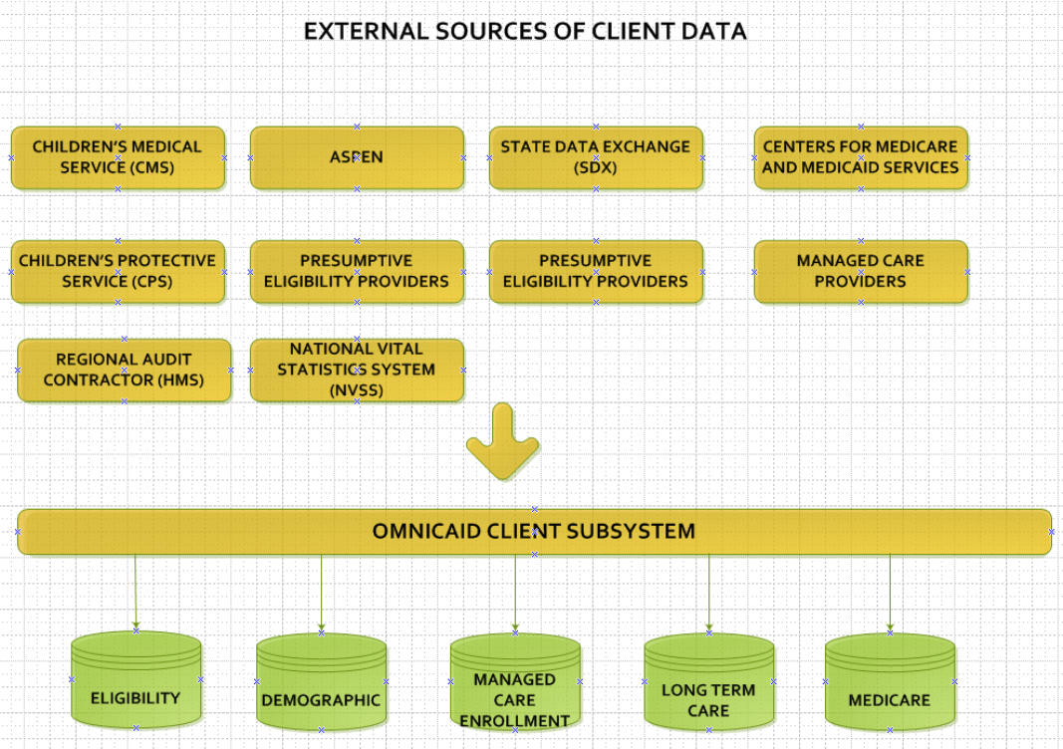

Most of the client data can also be updated online through Omnicaid windows with proper access authority. Client eligibility can also be verified and updated for presumptive eligibility through the Web Portal. The AVS (automated voice response system) provides another way to inquire on Client eligibility and to reaffirm their eligibility (Renewal). MEVSNet is yet another way to query client eligibility for providers.

The Client Subsystem has as its primary objective the maintenance of sufficient information about all clients to ensure access to Medicaid benefits. Client eligibility insures appropriate enrollment into Managed Care and proper payment of Medicaid claims. Following are the functions performed by the New Mexico OmniCaid MMIS Client Subsystem:

- Maintain (Add/Update) client data received from various sources
- Provide online search by multiple identifiers
- Provide inquiry of client summary data, and inquiry and update of client detail data on online windows
- Merge suspect duplicate clients
- Perform unmerge client activities
- Add presumptively eligible clients
- Generate reports automatically and on request
- Generate interfaces to outside entities
- Maintain an audit trail on online updates to client data
- Mass Transfer – Change of Ownership for LTC clients (CHOW)
- Medicaid Renewal Affirmation (via the AVRS)

4.1.2 Maintain (Add/Update) Client Data Received from Various Sources

There are several types of batch interfaces that provide input into the Client Subsystem.

- Demographic and Eligibility
- Long-term care
- Medicare
- Medicare buy-in
- Client Date of Death

4.1.2.1 Demographic and Eligibility Interface

There are four eligibility interfaces, excluding the interfaces that update only the client date of death, which are described separately.

- The State of New Mexico client eligibility system known as the Automated System Program and Eligibility Network (ASPEN). This system replaced the nearly 25-year-old ISD2 eligibility system and determines eligibility, benefit delivery and case management in support of New Mexico Human Services Department public assistance programs. The system was fully implemented in March, 2014.
- The SDX (State Data Exchange) daily interface was phased out with the implementation of ASPEN, but the monthly interface will be maintained for three years after ASPEN implementation to provide Omnicaid with retroactive eligibility information for date spans prior to the ASPEN conversion. ASPEN has a limitation in that it cannot add new retroactive eligibility spans with dates prior to the client’s conversion from SDX to ASPEN.
- The CPS (Child Protective Services) interface provides eligibility information on a daily basis about foster care children within the Child Protective Services Division of the Children, Youth, and Families Department. It identifies children who are eligible for state-funded medical services.
- The CMS (Children’s Medical Services) interface provides eligibility information on a weekly basis about children (under the age of 21) with disabilities and special medical needs. This interface comes from the Public Health Division of the Department of Health and identifies individuals who are eligible for these state-funded medical services.

As the eligibility interfaces are received, they are processed through various programs that act to edit the data and perform similar update processing for each interface. The ASPEN and CPS interfaces are received daily. The CMS interface is received weekly. The SDX interface is received monthly. All of the interfaces except SDX provide monthly reconciliation files, which are used to generate reports showing discrepancies in eligibility date spans between the external system and Omnicaid.

The daily and weekly eligibility interface processing is comprised of two different processes:

- Data capture, edit, and reformat
- Client database update

The data capture, edit, and reformat modules, ASPEN and legacy, perform the following major functions:

- Validates the incoming interface date, source, and number of records
- For CMS, reformats the CMS interface record format to the common interface record format used internally
- Ensures that the incoming interface data is not processed twice
- Performs data validity edits on the fields that are used to update the client database
- Creates error reports showing incoming transactions that failed edits
- Outputs a file of transactions that is used to update the client database

The client database update modules perform the following major functions:

- Adds, updates new client data (demographic, eligibility, patient liability)
- Adds, updates, closes and voids eligibility and patient liability spans
- Produces an audit trail detailing all changes made to the database
- Produces client database update error reports
- Produces possible duplicate client reports

SDX Monthly
The purpose of this interface is to add retroactive eligibility to SDX clients for the period of time prior to the client’s conversion to ASPEN, no earlier than three years since that conversion. No eligibility spans with an ASPEN source will be affected by this interface. The interface will add retroactive spans for periods of eligibility that don’t exist in Omnicaid.

Monthly Reconciliation
The purpose of the monthly reconciliation process is to determine if there are differences in the COE spans between what the external source of data reports and what Omnicaid contains.

Monthly Reconciliation for ASPEN
The monthly client reconciliation process is performed for ASPEN when ASPEN sends in the monthly reconciliation file on the first of the month. This file shows clients in the ASPEN system that are eligible for the upcoming month and beyond . The ASPEN reconciliation file is not processed through the daily ASPEN interface eligibility update module. It is only used to generate two reports. The RB312 report shows what COE spans exist on ASPEN that are not reflected in Omnicaid. For clients that have eligibility in ASPEN but don’t in Omnicaid, report RB313 reports the latest critical error that may have prevented the updates from being processed.

Monthly Reconciliation for CMS and CPS
The monthly client reconciliation process is performed after CMS and CPS send in a monthly reconciliation file, typically the second or third business day of the month for the prior month. As the monthly reconciliation files are received, they are processed through the normal eligibility interface update process, just like a daily or weekly file. After that, a reconciliation process is performed for CMS only. Changes were implemented on 10/30/2012 to discontinue the source-specific reconciliation process for CPS at the State’s request (RAT0585 - State change request 12-0856).

The reconciliation process for CMS reads all of the open-ended eligibility spans on the MMIS client master COE span table with an interface source of CMS, and reports any that do not appear on the State’s eligibility reconciliation file.

Note that this process is performed before the CMS weekly update file is applied, if one is submitted on the same day as the CMS monthly reconciliation file.

If CMS eligibility is entered online but it never gets sent to Omnicaid via the batch interface, it would never be closed unless someone manually closes it online.

4.1.2.1.1 Legacy Eligibility Interfaces

- The ‘legacy’ eligibility interfaces refer to the four eligibility interfaces in place prior to ASPEN. The legacy interfaces for ISD2 and SDX have been discontinued with the full implementation of ASPEN. The legacy interfaces for CMS and CPS will remain in place since those populations are not included in ASPEN.
- The legacy client eligibility interface will apply COE span updates based on COE hierarchy rules according to the COE Hierarchy Table for COE Date Span Overlaps Exhibit 5 in the system documentation exhibits. Spans will be added if there are no overlaps with existing COE spans on Omnicaid. If there are overlaps, then the incoming span may be added, bypassed, or cause the existing span to close, based on the hierarchy rules.

4.1.2.1.2 ASPEN Eligibility Interface
- Beginning in July 2013 ISD2 and SDX clients were converted over to ASPEN. This process was completed in March 2014. The ASPEN eligibility interface will not do any COE conversions. ASPEN will do any necessary conversions prior to sending us the span.
- The ASPEN client eligibility interface will not apply the COE hierarchy rules. Instead, the ASPEN system will apply those rules as clients are updated in ASPEN. Omnicaid will accept the incoming eligibility from ASPEN as the spans that should exist in Omnicaid, thus treating the ASPEN file as a type of replacement file. ASPEN will send any span that changes, along with all spans that begin on or after the begin date of the changed span, whether or not there are any changes to those spans. In general, the Omnicaid ASPEN eligibility interface will add ASPEN spans that don’t match existing Omnicaid spans, will void Omnicaid spans that don’t match incoming spans, and for matching spans, will update data on the existing Omnicaid span with any data on the incoming transaction span that is different, including the end date. If nothing has changed on matching spans, then the Omnicaid span is not touched.

4.1.2.2 Long-term Care Interface

- Effective April 2016, the CareLink NM to HSD interface, a Health Home program administered by MAD, was implemented. This Health Home program involves initially two behavioral health (BH) providers that enroll both FFS and managed care clients into Health Home and enter their health home information into Behavioral Heatlh Services Division’s (BHSD) system called STAR which is developed and maintained by a third party IT contractor, Falling Colors. The BH providers verify that recipients are Medicaid client using the Xerox NM web portal prior to enrolling them into a Health Home via the STAR system. STAR then sends a daily CareLink NM enrollment transaction interface to Omnicaid so that the Health Home enrollment is reflected in Omnicaid.

The CareLink NM interface adds/updates health home data in the Health Home (BHLTHHTB) table and care coordination data in the Care Coordination (BCARECTB) table. CareLink NM adds/updates health home spans with level code value ‘C’ (CareLink), and care coordination spans with level codes ‘6’(Health Home care coordination level 2) and ‘7’(Health Home care coordination level 3). Incoming CareLink NM transactions will also overlay any existing overlapping spans with the health home and care coordination information from the transaction. However, incoming health home and care coordination information from the MCO to HSD interface transactions are not allowed to update overlapping spans with the CareLink health home or care coordination levels.

- The Centennial Care MCO to HSD interface will add/update non-CareLink Level of Care and Setting of Care data in the Omnicaid Long Term Care span table. It will also add/update disability data in the Disability Type table, health home data in the Health Home table and care coordination data in the Care Coordination table. Incoming health home and care coordination information transactions from this interface are not allowed to update overlapping spans with the CareLink NM health home or care coordination levels described above.

- The ASPEN eligibility interface will update the patient payment amount in the Omnicaid Long Term Care Liability table.

4.1.2.3 Medicare and Medicare Buy-in Interface

The MMIS Client Subsystem also supports updates regarding Title XVIII (Medicare) entitlement. The Information Systems Bureau (ISB) of the Administrative Services Division (ASD) of the Human Services Department (HSD) receives the BENDEX interface from the Social Security Administration. ISB runs the BENDEX interface and forwards a file to the MMIS Client Subsystem to update the MMIS client database.

The MMIS Client Subsystem also receives updates about the results of the buy-in process by which the State purchases Medicare Part A, Part B, or both for Medicaid clients who are entitled to the buy-in. The Information Systems Bureau (ISB) of the Administrative Services Division (ASD) of the Human Services Department (HSD) handles buy-in processing (beginning and ending the buy-in and paying Medicare premiums to SSA). ISB forwards a client buy-in file to the MMIS Client Subsystem to update the MMIS client database. Note that once the ASPEN project has finished testing with CMS, the State will begin forwarding updates to the buy-in data using the TPS interface with CMS.

The State’s eligibility system, ASPEN, is responsible for the communication back and forth with CMS concerning Medicaid clients who are eligible for Buy-in, and all the premium information associated with that process. Once a month, Aspen forwards the CMS transactions that show Buy-in eligibility update activity for NM Medicaid clients to Omnicaid, which uses those transactions to update the client’s Medicare Part A / B eligibility spans. These files are sometimes referred to as response files.

The Client Medicare Entitlement / Buy-In Processing module performs the following major functions:

- Edits incoming data from the BENDEX and Buy-In interface files
- Updates the client Medicare tables with valid information from the interfaces
- Reports incoming transactions that fail edits

4.1.2.4 Client Date of Death

4.1.2.4.1 New Mexico Office of Vital Statistics Date of Death Interface

The New Mexico Office of Vital Statistics sends a monthly Date of Death file of clients who are deceased. This file is used by New Mexico MMIS to update a client’s date of death on the Client Detail table to prevent capitations from being generated and claims from being paid on deceased individuals.

4.1.2.4.2 RAC (HMS) Date of Death Interface

The recovery audit contractor HMS sends us a monthly Date of Death update file. This file is used by New Mexico MMIS to update a client’s date of death on the Client Detail table to prevent capitations from being generated and claims from being paid on deceased individuals.

4.1.3 Provide Online Search by Multiple Identifiers

The Client Selection Window controls online access to inquiry on client information. A user may request a search for an individual client or case based on search criteria entered. For clients and/or cases that meet the search criteria, the user may select them individually for inquiry.

To access information on an individual client, a user may specify up to three of the following key fields on the Client Selection Window:

First Second Third
Client ID Stand Alone – Unique Identifier Stand Alone – Unique Identifier
SSN Stand Alone – Unique Identifier Stand Alone – Unique Identifier
Medicare ID (HIC) Stand Alone – Unique Identifier Stand Alone – Unique Identifier
Last Name First Name (Full or Partial) Date of Birth
(Full or Partial) Sex Middle Initial
Race Sex
Race

Case Number Stand Alone – Unique Identifier Stand Alone – Unique Identifier
System ID Stand Alone – Unique Identifier Stand Alone – Unique Identifier
MCI Stand Alone – Unique Identifier Stand Alone – Unique Identifier

If the search results in multiple client matches, the system displays the list of matches on the Client Selection Window. The user may select a client from the displayed list and view that client’s record. When accessing information by client name, the MMIS uses the name entered by the user to determine where to begin selecting clients. A list of clients is displayed in alphabetical order by name, beginning with the first client that matches the selection criteria. The user can scroll through the list of clients on the selection screen, from the selected starting point to the end of the client database.

In all cases, if multiple records meet the selection criteria entered by the user, the user may review the list of clients and select an individual client for viewing. When the user has completed reviewing an individual client, the user may return to the selection window and select additional client records to view, or he or she may end the session.

If only a single client meets the selection criteria entered, the system displays that client’s information on the main window or on the first tab within the window. The user may view a particular data window by selecting the appropriate tab. Please refer to the Windows section of this document for the data that is available on each window.

4.1.3.1. Client IDs

There are numerous identification numbers associated with the client. The following is a summary of those IDs:

- Internal System ID (B_SYS_ID): System assigned random number. Unique to each client. Used as a key to client data on the tables.

- Alternate ID (B_ALT_ID): State assigned id numbers. May be more than one per client. All of the alternate IDs for a client point to the same internal system id on the alternate ID table.

- Current ID (B_CURR_ID): The concept of a Current ID was designed when the primary State assigned identifier was based on the client’s social security number and newborn clients were assigned temporary ids until an SSN was available, at which time they were assigned new “SSN-style’ IDs. The State has phased out the use of the Current ID due to security concerns. For the legacy CMS and CPS eligibility interfaces, the system determines the current ID from among all of the various alternate (state assigned) IDs. The field is populated by the system by looking at the IDs on the alternate ID table. This ID can change. The priorities for picking the current ID are as follows:

1 - Medicaid SSN style number (five leading zeros followed by SSN) (if more than one, use the most recent)
2 - Medicaid newborn number (looks like Medicaid style SSN with 5 leading zeros, followed by 94)
3 - Most recently updated state-only ID (CMS, CPS)

Since the ASPEN system uses a single random number identifier (MCI), the logic to
determine the Current ID for new clients added in the ASPEN eligibility interface is simply to set it to the swipe card id.

- Original ID (B_ORIG_ID): The system populates this with the first alternate ID assigned to the client. Once populated, it is never changed.

- MCI –This is a nine-digit internal identifier assigned to the client by ASPEN.

- Swipe Card id - In August 2003, we made changes for swipe cards (project 221116) to replace the SSN style ID printing on the swipe card with a random number ID, for security / privacy purposes. The ID we chose to use was the internal system ID prefaced by 00003. Every client has an alternate ID that consists of 00003iiiiiiiii, where iiiiiiiii, is the internal system ID, which points to the internal ID. This is known as the ‘swipe card id’.

Note that for ASPEN, the SSN-style id will no longer be created for new clients. Existing SSN-style ids will not be eliminated for current clients, but new clients created under ASPEN will no longer have an SSN-style id. Therefore, the current id for new ASPEN clients will be the swipe card id.

    - Provide Inquiry and Update of Client Data on Online Windows

The MMIS Client Subsystem windows may be used to inquire on, update, or add any client information on the MMIS Client Subsystem. The user is allowed almost complete control of the data in the Client Subsystem using the online windows. All fields, except for a few specifically identified fields, may be updated online.

The user may perform the following types of update activities using the online windows of the Client Subsystem:

- Update client data
- Delete client data
- Void client eligibility span data
- Add, update, or void lockin span data
- Add a new client
- Replace a lost or stolen swipe card

4.1.4.1 Update Client Data

In update mode, the first window presented is the Client Detail Window. All information on this window, except the internal System ID and the MCI ID, is updateable, and all updateable fields are unprotected. The worker clicks on the tab corresponding to the detailed information that needs to be updated. There are ten tabs to the Client Detail Window.

- Detail – non-span information, mostly demographic, about the client. FPL % and copay information is also on the Detail tab.
- Residential Address – residential addresses by date, including phone numbers, geographical county, both current and historical
- Other Address – Current Mailing, Authorized Representative, Payee, and Case Management addresses for the client. Names and telephone numbers are also included.
- Previous information – previous client IDs, Medicare claim numbers, and client names
Note that if there is more than one swipe card id listed here, it means that another client was merged into this client. Users can attach additional IDs, or remove IDs, from this window.
- Eligibility – Multiple eligibility spans showing the category of eligibility, eligibility begin and end dates, client and ASPEN MCI ID, Case Number, etc. Medicare – information about the client’s enrollment to Medicare Parts A B, C and D Long-term care – information about the client’s long-term care spans and patient liability amounts
- Lock-in – Enrollment spans for Managed Care as well as information about the provider and plan in which the client is enrolled (See Section 14.0 Managed Care Subsystem for this information)
- Managed Care – Client MCO choice spans, Care Coordination, and Health Home spans.
- Swipe card – information about all swipe cards issued to a Medicaid client and a field that allows the user to request a replacement of a lost or stolen swipe card
- MSQ – information about medical services questionnaires that were sent to the client by the TPL subsystem

Client demographic data (such as name, date of birth, sex, race) may be changed but not deleted. Addresses can be changed but not deleted.

4.1.4.2 Delete Client Data

Certain client data may be deleted, such as:

- Responsible person
- Telephone number
- Lock-in span
- Medicare entitlement
- Buy-in span
- Long-term care span
- Patient liability span
- Copay span
- Care Coordination span
- Health Home span

Deleting may be accomplished using the delete key for individual fields or by selecting a span of data and either right clicking and selecting the DELETE option or clicking the delete microbutton. Edits protect the user from deleting inappropriately.

4.1.4.3 Void Client Eligibility Span Data

Eligibility information is kept, even when incorrect, since it is needed to support claims history. Therefore, eligibility information may be voided but may not be deleted. However, one exception does exist. The user can delete an incorrectly entered eligibility span on the same day it is added. If the user determines that the information is incorrect for an eligibility span, he or she marks the incorrect span as “void” and adds one or more new spans to provide the correct data. Edits assist the user in correctly voiding these spans.

4.1.4.4 Add, Update, or Void Lockin Span Data

There are numerous types of lockin spans that can be maintained for clients. Some of these types are used to support Managed Care enrollment and exemptions. For details about these please refer to the documentation under Section 4 Client Lockin Window and Section 14 Managed Care Narrative.

Other lockin types are discussed in detail in the documentation under Section 4 Client Lockin Window.

4.1.4.5 Add a New Client

Under certain situations, the user may need to add a new client. Examples of situations in which the user may add a new client include, but are not limited to, the following:

- A client is presumptively eligible and has not yet been received via an eligibility interface.
- A client was issued a Medicaid card and submitted by the eligibility interface, but the client’s record failed certain fatal edits and the record was never added to the Client Subsystem.
- A newborn child is added retroactively.

The user can add a new client from the Client Selection Window by clicking on the NEW pushbutton. This action brings up the Client Detail functional group. The system will ask if the client is an ASPEN client (this affects the editing rules).

When the user saves the information on the new client, online edits are performed to ensure that a minimum set of data has been entered for the new client. The required data includes:

- Client ID
- Client name
- SSN
- Sex
- Race
- Date of birth
- Primary Language and Ethnicity codes (ASPEN clients only)
- Residential Address and Begin Date
- Geographic County
- MCI ID (ASPEN clients only)
- At least one eligibility span
  - Eligibility begin date
  - Eligibility end date
  - Category of eligibility
  - Federal match
  - Case number
  - Administrative county (legacy clients only)

When a new client is added, the system checks for both exact duplicate clients and suspected duplicate clients. The client being added is considered an exact duplicate of an existing client when any of the following three conditions exist:

- The new client’s SSN matches that of an existing client.
- The new client’s last name, full first name, sex, and DOB match an existing client; both the new and existing client have no SSN on file.
- The new client’s last name, full first name, sex, and DOB match an existing client; the new client has a temporary SSN and existing client has no SSN on file.

If the client being added is an exact duplicate of an existing client, the system asks the user if he or she wishes to enter the new ID as an alternate ID. If the answer is yes, the system creates an alternate ID cross-reference table entry and redetermines the current client ID.

If the client being added is not an exact duplicate of an existing client, the new client is considered a suspect duplicate of an existing client when his or her last name, the first four letters of his or her first name, sex, and DOB match an existing client.

4.1.4.6 Replace a Lost or Stolen Swipe Card

The Swipe Card window displays information about all swipe cards issued to a Medicaid client. The user can request replacement of a lost or stolen swipe card by checking an indicator.

4.1.5 Merge Suspect Duplicate Clients

In the New Mexico OmniCaid MMIS, a client may legitimately have any number of user-assigned client IDs. However, the client will only have one internal Client System ID (the number by which the client is known to the system). The incoming eligibility interfaces are supplied by different agencies, each of which may have its own client ID. In some situations, the client’s ID may change even within a single eligibility agency. To support this situation, the New Mexico OmniCaid MMIS maintains a cross-reference of alternate client IDs for each client. The alternate ID is the user defined identification number. All of the alternate IDs for a client point to the same internal Client System ID.

The Client System ID does not change except in the case of a duplicate client merge, where one of the two client’s alternate IDs will be automatically cross-referenced to the others.

For certain clients, the incoming interface information is different enough that the New Mexico OmniCaid MMIS cannot recognize that the client is already on the client database. The result is that the client is added and is considered as two different people. If it is subsequently determined that these two records are indeed for the same person, then it is necessary to merge the duplicate client records into one and to cross-reference the IDs.

The New Mexico OmniCaid MMIS provides the capability to merge information for a suspect duplicate client using either an online window or an on-request batch process.

      - Online Client Merge
A user can merge one of the client’s information into the other client’s information using the online client merge windows. The user can specify which client’s information to keep. The other client’s data will be deleted from the client database. As part of this process, the system updates the appropriate client cross-reference tables to reflect the merge. It is the responsibility of the user to “screen print” all client-related information of the client to be merged before performing the merge. It is also the user’s responsibility to transfer claims under the ID of the client being merged to the ID of the target client using the Client Claims Transfer Window. Finally, it is the user’s responsibility to verify and correct, if necessary, the updated client’s information on all client-related tables after completing the merge.

      - Batch Client Merge

As part of the ASPEN project, a batch client merge process was developed that uses an adhoc input file created by the state to identify multiple clients to merge at one time. This batch process contains all of the functionality of the online process and is documented in greater detail in the client interfaces section of the system documentation.

4.1.6 Perform Unmerge Client Activities

A process is necessary for separating or “unmerging” clients when two individuals have incorrectly been assigned the same client ID. The result is that two clients’ data is intermingled.

The scope of “unmerging” is based on the user review of all information about the client in all subsystems, e.g., Prior Authorization, Third Party Liability, and the Client Subsystem. The user must identify which data belongs to which person. Usually, the user will request a print for all related records for the individual.

Based on this research, the user may choose to delete information from the Client Subsystem and from other subsystems. For example, if there is a prior authorization identified as belonging to client #1 and it really should belong to client #2, the user may request to delete the prior authorization. Afterwards, the user will add the prior authorization to client #2 in a separate transaction.

The user has the following options. More than one can be selected.

- Print all related records. This option is selected to obtain a full print of the client’s information. This printed output may be part of the research that the user performs before actually requesting to delete/remove information.
- Delete all related records
- Delete client
- Delete TPL resource, billing, recovery, and MSQ information
- Delete prior authorization
- Delete client ID cross-reference

A print for the selected record(s) automatically is processed when any delete or remove options are selected.

When the user saves the delete or removal request, a batch request transaction is created. That night, the system deletes the requested records on the New Mexico OmniCaid MMIS. Once the system deletes the information that was incorrectly associated with the client, the user can then add the second client to the database using the client add/update windows.

Since the online window for the unmerge function does not update any data but, rather, is merely the vehicle for producing a batch request, the user has the opportunity to delete the requested unmerge activities so long as he does it before the nightly batch cycle. When the “unmerge” is completed and the clients have separate client information, claims history must be cleaned up by transferring claims to the correct client using the Client Claims Transfer Window.

4.1.7 Add Presumptively Eligible Clients via the Web

Certain providers may add clients who are identified as presumptively eligible to the Client Subsystem via the web. These providers are called Presumptive Eligibility Determiners (PEDs) and must meet certain specifications in the Provider Subsystem. PEDs may be counselors in the public schools or other persons who are in a position to recognize a client in need of medical services. PEDs must be active providers in the New Mexico OmniCaid MMIS.

The PED accesses the New Mexico Medicaid Web Portal to add a client to the Client Subsystem. The data required includes the following:

- PED’s provider ID
- Child’s SSN
- Child’s date of birth
- Child’s gender
- Child’s race
- Child’s geographic county
- Child’s administrative county
- Child’s last name
- Child’s first name
- Child’s MCO choice

The Web portal does high-level data editing, and then accesses the Omnicaid Client Subsystem to perform all the normal edits that are performed for an online transaction to add a client.

Please refer to Section 17 Web Based Functionality for further details about this function.

4.1.8 Generate Reports Automatically and On Request

The Client Subsystem produces a number of reports. Some reports are automatically produced based upon actions that take place within the system. Other reports are produced only when requested by an authorized user. A detailed list of these reports, the circumstances under which they are generated, layouts, and explanations of these reports may be found in Section 4.3 Client Subsystem Reporting Functionality in this document.

Several of the existing New Mexico OmniCaid Client Subsystem reports are produced using information found in the MMIS data warehouse. A desktop inquiry application is available to provide access to this information for authorized users.

4.1.9 Generate Interfaces to Outside Agencies and Systems

The Client Subsystem includes numerous external interfaces to other agencies/systems, in addition to interfaces with other Omnicaid subsystems. The external entities include ASPEN, CMS (Centers for Medicare and Medicaid Services), HSD, TPA, IHS, COBA, Focus, Finity, Spectrum, the IRS, and Xerox PBM, EDI, Managed Care providers and web support systems.

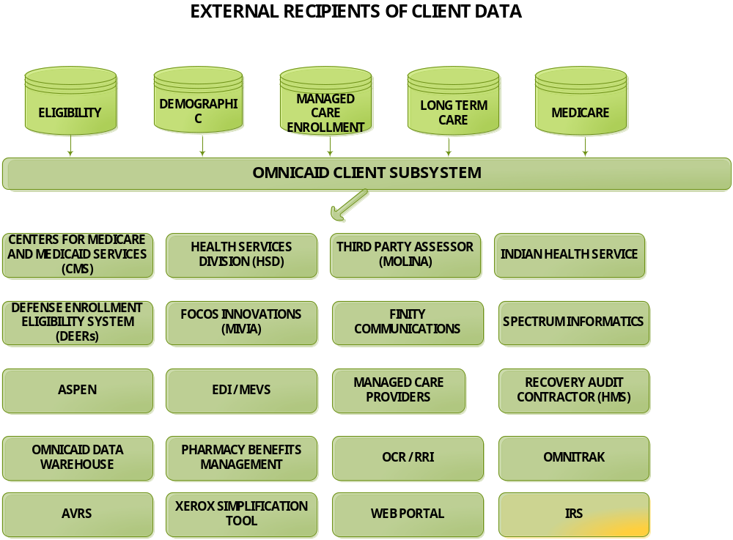

For additional information on each of the interfaces supported by the Client Subsystem, please refer to Section 4.4 Client Subsystem Interface Functionality in this document.

4.1.10 Maintain an Audit Trail on Updates to Client Data

When client data is added or updated online, the audit user, audit date, and audit time are stored in three columns in the row of the table that was processed. This information provides a history by recording when and who modified this row last. The audit fields can be accessed online by selecting the Audit function on the action bar. In the Client Subsystem, the date and time that the row was originally added, as well as the source, are also maintained. Therefore, for a given client, the system tracks who originally created the client records and when they were first created, as well as the last time they were updated and by whom. Please note that up to date audit add and update information will be available only after the user has exited the affected client and retrieved the client data again. Each batch interface that updates data in Omnicaid has their own customized audit trail reporting.

    - Mass Transfer – Change of Ownership for LTC Clients

The system supports a mass transfer or change of ownership (CHOW) to transfer LTC clients from one provider to another. A CHOW request may be entered online using the CHOW Mass Transfer Request window. In the nightly Client batch cycle, the request(s) will be processed and an audit report will be generated. There can be more than one request entered each day, but there can only be one request per provider. The requestor enters a “transfer from” provider ID, a “transfer to” provider ID, and an effective date into the request window. The system calculates the end date of the “transfer from” provider as one day less than the effective date entered for the “transfer to” provider. The end date is displayed on the window for informational purposes, as are the providers’ names and provider types. The two providers must be the same provider type and the “transfer to” provider must be active on the entered effective date.

The nightly batch process will search the LTC span table for all clients that have spans containing the “transfer from” provider. If the end date on the span is prior to the effective date of the CHOW, then nothing is done. If the begin date on the span is prior to the CHOW effective date, then the span is closed with an end date of one day prior to the CHOW effective date. Then, a new LTC span is added containing the “transfer to” provider, with the begin date equal to the CHOW effective date and the end date equal to the end date on the original span. Finally, if the existing LTC span begin date is after the CHOW effective date, then the provider ID is updated on that span to the “transfer to” provider ID.

    - Generation of IRS 1095B Forms

The Affordable Care Act requires that all nonexempt individuals either have minimum essential coverage (MEC), or pay the individual shared responsibility payment. To enable Medicaid clients to meet this requirement, beginning with tax year 2015, State Medicaid agencies are required to report MEC for all its non-exempt individuals on a 1095-B form documenting months of coverage for the prior tax year and provide to the IRS an electronic file 1095-B documenting all the individuals for whom a 1095-B form was created.

Omnicaid supports this requirement with 1095-B form history tables, batch processes, interfaces with print vendors, a client detail 1095 window tab, and web functionality to transmit data to the IRS and to allow the user to view, reprint and correct 1095-B forms. The following lists the key functions supported by Omnicaid for 1095-B generation:

- Annual batch process to create the 1095-B form history for the prior tax year
- Annual batch process to create and transmit a 1095-B print vendor extract to the selected print vendors
- Annual web process that reads the 1095-B form history for the prior tax year and formats it according to IRS specifications and transmits it to the IRS, keeping track of transmission file acknowledgements and providing returned errors from the IRS to the Omnicaid batch system.
- Periodic batch correction process that analyzes client data for the clients who had 1095-B forms generated for the prior tax year and creates 1095-B correction forms for clients whose SSN has changed since the last form generation, or who has had MEC added retroactively for the prior tax year, since the original or last corrections were generated for the prior tax year. Coverage that was lost retroactively is not reported on a corrected form. The reasoning behind this is if the State told the client during a given year that they had coverage that year, then the client wouldn’t purchase their own health insurance. Subsequently, if the following January shows the client lost coverage for the prior tax year retroactively and the client received a 1095-B tax form for that year showing no coverage, then they will be liable to pay the penalty for not having coverage, even though they were told at the time they did have coverage.
- 1095-B window tab under client detail showing 1095-B form history
- On demand correction and reprint requests entered online in Omnicaid via the 1095-B window tab
- On demand reprint capability through the client web portal. Clients can download and print their own copy of the 1095-B through the client web portal. Correction requests are not allowed via the web portal since we don’t want clients requesting corrections if no 1095-B related data has changed. If their data has changed, they need to speak to a help desk representative to ensure that the data is changed in the source system that feeds Omnicaid.
- Batch printing of the IRS return error files received from 1095-B transmissions to the IRS. These reports will need to be worked manually to address any issues with the data. Form corrections will have to be manually requested through Omnicaid for affected clients.
- Note that 1095 form history data will not be stored in the data warehouse.

